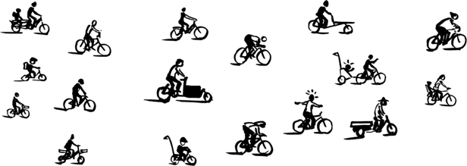
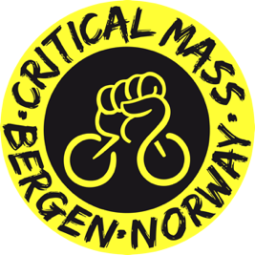
Critical Mass-Starter Checklist

1. Basics & Intent
☐ Find 1–3 people you enjoy planning this with
☐ Clarify your main goals (visibility, fun, political message, growth…)
☐ Decide how “organized” you want to appear (visible organizers vs. loose structure)
☐ Think of your target audience and plan accordingly (all people who want to bike? activists? families?)
☐ Decide how often you can realistically ride (monthly is common)

2. Identity & Structure
☐ Pick a name (usually Critical Mass + City)
☐ Agree on a simple mission or slogan (can be used on social media)
☐ Decide on date & time (many cities choose last Friday of the month)
☐ Decide whether the ride has a fixed route or goes spontaneously
(Logo, website, flags, branded vests, stickers, maps of the route make the whole thing more legit.)

3. Team Communication & Safety
☐ Set up a simple way to communicate (messenger group, shared doc)
☐ Decide who leads the ride, who stays at the back, who corks (amount depends on group-size)
☐ Talk about basic safety: closing gaps, dealing with traffic/emergency vehicles, critical route-sections
☐ Decide how to handle potential conflicts with motorists (joyful attitude deescalates and looks inviting)

4. Spreading the Word
☐ Create a broad online presence (lots of CMs are on Instagram; create Facebook events)
☐ Tell people directly: friends, bike groups, activists, organisations, schools…
☐ Make and share posters (digital and print), flyers, stickers…
(Media outreach, a website and an online campaign are more work but very effective.)

5. Before the Ride
☐ Share meeting point, time, route, other info online. The more you post about it, the more people come
☐ Get at least one big speaker for music (maybe you’ll need a cargo bike/trailer) and make a playlist
☐ Talk through “what if” scenarios within the team (rain, delays, conflicts…)

6. During the Ride
☐ Welcome people, give a speech (megaphone!), explain principles like corking
☐ Keep the group together and move out of the way if emergency vehicles want through
☐ Take photos or videos (to share online, make reels, send to the press etc.)
☐ Enjoy the ride 🚲

7. After the Ride
☐ Share photos/videos online and thank participants
☐ Talk about what worked, what didn’t, get feedback
☐ Plan the next ride
☐ Improve gradually and grow the mass
Also recommended
- Take meeting notes and plan tasks between rides
- Stay independent from political parties
- Choose a finish line where community can hang-out
- Research CM history and clarify your values
- Agree on how to deal with police
- Ask city bike programs for attendee discount codes
- Use app Critical Maps so people can find the ride

